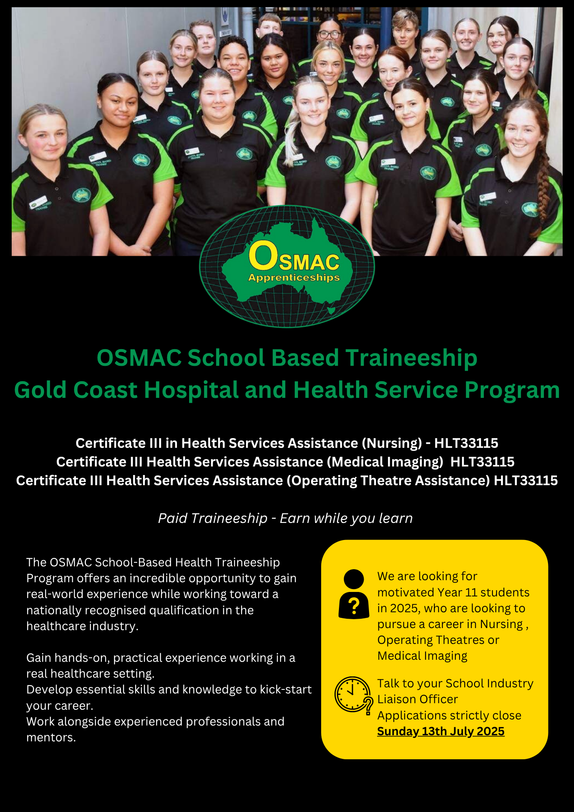

**INSERT SCHOOL PHOTO**

|  |  |
| --- | --- |
| **FIRST NAME:** |  |
| **MIDDLE NAME:** |  |
| **LAST NAME:** |  |
| **NAME OF SCHOOL:** |  |
| **STUDENT SCHOOL EMAIL:** |  |
| **STUDENT PERSONAL EMAIL:** |  |
| **RESIDENTIAL ADDRESS:** |  |
| **MOBILE NUMBER:** |  |
| **CURRENT SCHOOL YEAR LEVEL:** |  |
| **DATE OF BIRTH:** |  |
| **INDUSTRY LIAISON OFFICER /SCHOOL CONTACT NAME & EMAIL:** |  |
| **PARENT/GUARDIAN NAME:**  **PARENT/GUARDIAN MOBILE:**  **PARENT/GUARDIAN EMAIL:** |  |
| **USI NUMBER:** [**https://www.usi.gov.au/students/find-your-usi**](https://www.usi.gov.au/students/find-your-usi) |  |
| **T -SHIRT SIZE** | * **XS - SIZE 6** * **S - SIZE 8** * **M - SIZE 10** * **L - SIZE 12** * **XL - SIZE 14** * **XXL - SIZE 16** |
| **WHICH BEST DESCRIBES YOUR WORK TO RIGHT IN AUSTRALIA** | * **AUSTRALIAN CITIZEN** * **AUSTRALIAN PERMANENT RESIDENT** * **NZ PASSPORT HOLDER (MORE THAN 6 MONTHS RESIDENCY)** * **VISA HOLDER, VISA TYPE NUMBER: _________________** |
| **ARE YOU CURRENTLY ENROLLED IN, OR HAVE YOU COMPLETED ANOTHER APPRENTICESHIP/ TRAINEESHIP?** | * **YES** * **NO** |
| **CONFIRMED YOUR SCHOOL ALLOWS YOU TO ATTEND WORK ON WEDNESDAY?** | * **YES** * **NO** |
| **WHICH DEPARTMENT ARE YOU INTERESTED IN WORKING IN?**  **PLEASE PICK 2 AREAS** | * **DIRECT NURSING PATIENT/WARD CARE** * **OPERATING THEATRE ASSISTANTS** * **MEDICAL IMAGING – (NUCLEAR MEDICINE)** |
| **DO YOU IDENTIFY AS ABORIGINAL/TORRES STRAIT ISLANDER?** | * **YES, PLEASE SPECIFY: ___________________** * **NO** |
| **PLEASE ADVISE IF THERE ARE ANY RESTRICTIONS TO YOU COMPLETING THE FULL SCOPE OF THE ROLE (I.E. SHOWERING, TOLIETING, DRESSING MEN AND WOMEN)** | * **NO – I DO NOT HAVE ANY RESTRICTIONS** * **YES – IF SO WHY:** |

**SELECTION CRITERIA – Please take a moment to respond to the following questions in your own words**

**Criteria 1: Provide an introduction that includes your full name, school, grade, and background (such as family, interests, sports, community involvement, volunteering, and hobbies)**

|  |
| --- |
|  |

**Criteria 2: Why are you interested in applying for the Health Services Assistance Traineeship? What are your**

**personal and professional goals, and how will this traineeship help you achieve them?**

|  |
| --- |
|  |

**LITERACY/NUMERACY QUIZ – Please answer the below questions**

1. **Select the most appropriate word to replace the word that is underlined:**

**Workers in the Health Industry must be careful to ensure patient confidentiality.**

* **Gossip**
* **Lies**
* **Conversation**
* **Privacy**

1. **You have been asked to monitor the fluid intake of a patient. How much fluid (in millilitres) have they consumed in total if they drink the following quantities:**

**Breakfast: 500mls of water**

**Lunch: 290mls of milk**

**Afternoon Tea: 300mls of water**

**Dinner: 600mls of water**

**ANSWER: _____________________________________________________________________________**

1. **Select the most appropriate word to replace the word that is underlined:**

**Aged care workers provide support to the elderly.**

* **Assistance**
* **Choices**
* **Knowledge**
* **Transport**

1. **You are conducting a stocktake. If you have 13 boxes of masks and each box contains 20 masks, how**

**many masks do you have in stock?**

**ANSWER: _____________________________________________________________________________**

1. **Select the missing, correctly spelt word for the following sentence:**

**As people get older, their skin becomes thinner and can be easily…**

* **Dameged**
* **Damagged**
* **Damaged**
* **Demaged**

1. **Based on the list below, which of the following procedures for washing your hands is in the correct order?**

**Step 1 - When soap has foamed, rinse well with water.**

**Step 2 - Dispose of the paper towel correctly.**

**Step 3 – Thoroughly rinse hands with water.**

**Step 4 – Dry hands thoroughly using a clean paper towel.**

**Step 5 – Use medicated hand wash and rub thoroughly over both hands for 20 seconds.**

* **Step 2, Step 3, Step 4, Step 1, Step 5**
* **Step 3, Step 4, Step 5, Step 1, Step 2**
* **Step 3, Step 5, Step 1, Step 4, Step 2**
* **Step 5, Step 2, Step 1, Step 3, Step 4**

1. **If you work 70 hours in a fortnight and earn $14.00 an hour, what will your earnings per week be before tax deduction?**

**ANSWER: _____________________________________________________________________________**

1. **Based on the following information, what is the goal of an infection control program?**

**An infection occurs when a pathogenic microbe is able to multiply in the tissue in which it is lodged.**

**An infectious disease is one that is communicable or contagious. These terms mean that the disease**

**can be transmitted (spread) in some way from one host to another. Therefore, it is essential that**

**health care works have a full understanding of infection control policies and procedures.**

* **To prevent disease transmission from patient to staff**
* **To prevent disease transmission from staff to patient**
* **To prevent disease transmission from patient to other patients**
* **All of the above**

1. **Based on the following information, how does Mr Smith get to the bathroom?**

**A home nurse is at Mr Smith’s home to assess his need for personal care assistance. Mr Smith is 80 years**

**old. He says he has difficulty lifting his arms over his head and cannot get his shirts off easily. He can use**

**his frame to walk to the bathroom but needs assistance to get the water temperature correct, to step**

**into the shower and he also needs reminding to hold the rails inside the shower.**

* **Using a walking stick**
* **Staff Assistance**
* **Using a walking frame**
* **Using the railing**

1. **Based on the following article excerpt, what is meant by the term “contagious”?**

**Other organisms such as the flu virus are highly contagious. This means that they can spread very easily**

**from one person to another. You do not have to be in contact with the virus for very long to catch it and**

**get sick. Most people have an immune system to prevent infections. Your immune system is your**

**natural defence against illness. However, as people get older, the immune system is less effective due to**

**the ageing process.**

* **A condition that is easily spread from one individual to another**
* **Another name for the flu**
* **Something that only effects old people**

1. **What do you think the term “nil by mouth” means for patient awaiting surgery?**

* **The patient can suck on ice cubes and lollies only**
* **The patient is not allowed to eat any food**
* **The patient is not allowed to eat any food or drink**

1. **Your shift at the hospital starts at 7.00am and finishes at 3.00pm. You get a 30-minute unpaid lunch**

**break per shift. What is the paid duration of your shift?**

* **8 Hours**
* **7.5 Hours**
* **7 Hours**

#### Medical History

OSMAC Group Training is aware of its obligation to anti-discrimination legislation and information provided by applicant will be used in a manner complimentary to the fulfilment of those obligations.

Have you ever suffered from?

|  |  |  |  |  |
| --- | --- | --- | --- | --- |
| Yes |  | No |  | Back Problems |
|  |  |  |  |  |
| Yes |  | No |  | Bronchitis |
|  |  |  |  |  |
| Yes |  | No |  | Migraines |
|  |  |  |  |  |
| Yes |  | No |  | Dermatitis |
|  |  |  |  |  |
| Yes |  | No |  | Eyesight |
|  |  |  |  |  |
| Yes |  | No |  | Arthritis |
|  |  |  |  |  |
| Yes |  | No |  | Asthma |
|  |  |  |  |  |
| Yes |  | No |  | Epilepsy |
|  |  |  |  |  |
| Yes |  | No |  | Hearing Problems |
|  |  |  |  |  |
| Yes |  | No |  | Fainting/ Blackouts |

|  |
| --- |
| **List all injuries, illnesses and allergies that you have suffered from?** |
|  |
| **Do you have any fear of heights or confined spaces?** |
|  |
| **Do you require any reasonable adjustment to effectively perform the duties of the traineeship? If yes, are you able to please list them so we know how to best support you?** |
|  |
|  |

**Are you willing to undergo a preemployment medical inclusive of drug and alcohol testing?**

* Yes
* No

**Statement by Applicant**

I, the undersigned declare that the above information has been answered truthfully and to the best of my knowledge. I further understand that if false or misleading information has been supplied it may result in the termination of my employment.

|  |  |
| --- | --- |
| Student Signature: | Date: |

**Please sign below to confirm that you are available on the designated training day, weekly, as well as up to 3 days per week during the school holidays.**

**Please note that all trainees must have reliable and sufficient transportation to attend their scheduled shifts and RTO training sessions. If a trainee is unable to meet this requirement, we reserve the right to cancel the traineeship. It is the trainee’s responsibility to ensure they can consistently commute to and from work for the duration of the program.**

#### Students who are successful securing a traineeship will be required to complete the following prior to commencing their traineeships:

* National Police Check (paid by trainee upfront, reimbursed by OSMAC)
* Blue Card (paid for by OSMAC)
* Film Consent Form
* VPD Vaccination Forms

Student Signature: ___________________________________

Guardian Signature: __________________________________

**Please include the following supporting documentation with your expression of interest:**

* Copy of your Resume
* Cover Letter
* Most recent school report card
* Letter of recommendation from your school confirming their support for you to attend the traineeship on the designated day

**Please note that, due to the nurse educators' availability on specific days, we cannot accommodate any changes to the schedule once the traineeship has started.**

**Please ensure that this expression of interest is completed in full; incomplete applications will not be considered.**

**Email your application and supporting document in one email to;**

**health@ogt.com.au**