

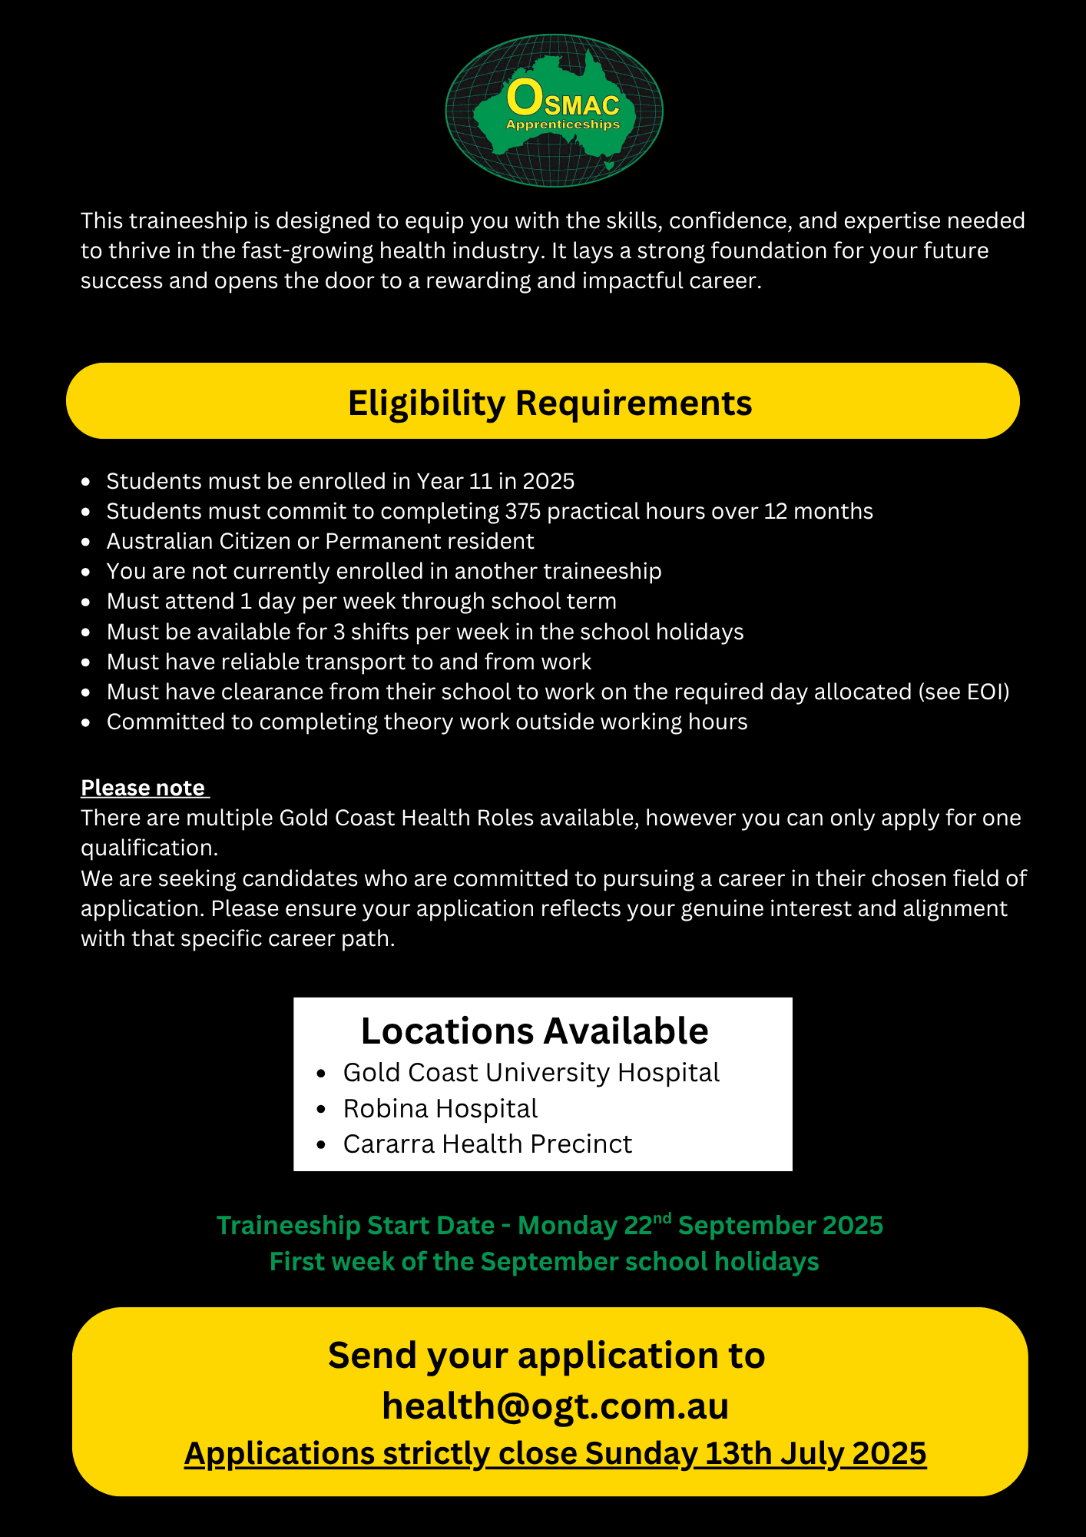

INSERT SCHOOL PHOTO

FIRST NAME:
MIDDLE NAME:
LAST NAME:
NAME OF SCHOOL:
STUDENT SCHOOL EMAIL:
STUDENT PERSONAL EMAIL:
RESIDENTIAL ADDRESS:

MOBILE NUMBER:
CURRENT SCHOOL YEAR LEVEL:
DATE OF BIRTH:
HAVE YOU COMPLETED/ ARE YOU COMPLETING A CERT II BUSINESS:
ARE YOU CURRENTLY ENROLLED IN, OR HAVE YOU COMPLETED ANOTHER APPRENTICESHIP OR TRAINEESHIP?:
INDUSTRY LIAISON OFFICER /SCHOOL CONTACT NAME & EMAIL:
PARENT/GUARDIAN NAME:
PARENT/GUARDIAN MOBILE:
PARENT/GUARDIAN EMAIL:
USI NUMBER: HTTPS://WWW.USI.GOV.AU/STUDENTS/FIND-YOUR-USI
T -SHIRT SIZE | - XS - SIZE 6  - S - SIZE 8  - M - SIZE 10  - L - SIZE 12  - XL - SIZE 14  - XXL - SIZE 16
WHICH BEST DESCRIBES YOUR WORK TO RIGHT IN AUSTRALIA | - AUSTRALIAN CITIZEN  - AUSTRALIAN PERMANENT RESIDENT  - NZ PASSPORT HOLDER (MORE THAN 6 MONTHS RESIDENCY)  - VISA HOLDER, VISA TYPE NUMBER: _________________
WHAT DAY IS SUITABLE FOR RELEASE FROM SCHOOL (WEEKLY) | - TUESDAY  - WEDNESDAY  - THURSDAY
WHICH DEPARTMENT ARE YOU INTERESTED IN WORKING IN? PLEASE PICK 3 AREAS | - OPERATIONAL LOGISTICS  - FINANCE  - NUCLEAR MEDICINE – ADMIN  - MEDICAL IMAGING – ADMIN  - ORAL HEALTH SERVICES – BUSINESS SUPPORT TEAM  - SURGICAL & CRITICAL CARE/CLINICAL SUPPORT  - ACCOUNTING  - ADMIN – EMERGENCY SUPPORT SERVICES  - LEARNING & DEVELOPMENT
DO YOU IDENTIFIY AS ABORIGINAL/TORRES STRAIT ISLANDER? | YES / NO PLEASE SPECIFY: ___________________

SELECTION CRITERIA – Please take a moment to respond to the following questions in your own words

Criteria 1: Provide an introduction that includes your full name, school, grade, and background (such as family, interests, sports, community involvement, volunteering, and hobbies)

Criteria 2: Why are you interested in applying for the business administration traineeship? what are your
personal and professional goals, and how will this traineeship help you achieve them?

LITERACY/NUMERACY QUIZ – Please answer the below questions

- Select the most appropriate word to replace the word that is underlined:

Workers in the Health Industry must be careful to ensure patient confidentiality.

- Gossip
- Lies
- Conversation
- Privacy

- Which sentence is grammatically correct?

- The manager and the employees is working on the project.
- The manager and the employees are working on the project.

- A business has 3 departments: Sales (40%), Marketing (30%), and Operations (30%). If the company has 200 employees, how many employees work in each department?

Sales: _________________
Marketing: _________________
Operations: _________________

- A business meeting lasts 2 hours 15 minutes. If it starts at 9:30 AM, at what time does it end?

ANSWER: _____________________________________________________________________________

- Identify how many spelling errors are in the following sentence:

The docter will examin the pateint's vitals and prescibe medicine for ther condition.

- 5
- 4
- 3

- You need to schedule a critical meeting. You’re available from 9.30am – 2.30pm.

Tina is available from 10.30am -2.30pm.
Chris is available from 12pm to 4pm.
The staff do not enjoy taking meetings during lunch but will if it’s important.

When are all three of you available to start a 1-hour meeting?

- 10.30 am
- 12.00 pm
- 1.00 pm
- 1.45 pm

- If a product launch is scheduled for March 15th and the team needs to prepare for 45 days, when should the preparation begin?

- 29th January
- 28th February
- 29th April

- Your shift at the office starts at 7.00am and finishes at 3.00pm. You get a 30-minute unpaid lunch
break per shift. What is the paid duration of your shift?

- 8 Hours
- 7.5 Hours
- 7 Hours

- You need to send a letter to a patient to inform them about their upcoming appointment. Write a brief, polite letter confirming the appointment details, including the date, time, and location.

Patient Name: John Smith
Date/Time of Appointment: 2pm, 15th June 2025
Location: Podiatry Clinic, Gold Coast University Hospital (Lower Ground Floor)
1 Hospital Boulevard, Southport 4215
Reason for appointment: Wound Dressing

Medical History

OSMAC Group Training is aware of its obligation to anti-discrimination legislation and information provided by applicant will be used in a manner complimentary to the fulfilment of those obligations.

Have you ever suffered from?

Yes |  | No |  | Back Problems
Yes |  | No |  | Bronchitis
Yes |  | No |  | Migraines
Yes |  | No |  | Dermatitis
Yes |  | No |  | Eyesight
Yes |  | No |  | Arthritis
Yes |  | No |  | Asthma
Yes |  | No |  | Epilepsy
Yes |  | No |  | Hearing Problems
Yes |  | No |  | Fainting/ Blackouts

List all injuries, illnesses and allergies that you have suffered from?
Do you have any fear of heights or confined spaces?
Do you require any reasonable adjustment to effectively perform the duties of the traineeship? If yes, are you able to please list them so we know how to best support you.

Are you willing to undergo a preemployment medical inclusive of drug and alcohol testing?

- Yes
- No

Statement by Applicant
I, the undersigned declare that the above information has been answered truthfully and to the best of my knowledge. I further understand that if false or misleading information has been supplied it may result in the termination of my employment.

Student Signature: | Date:

Please sign below to confirm that you are available on the designated training day, weekly, as well as up to 3 days per week during the school holidays.

Please note that all trainees must have reliable and sufficient transportation to attend their scheduled shifts and RTO training sessions. If a trainee is unable to meet this requirement, we reserve the right to cancel the traineeship. It is the trainee’s responsibility to ensure they can consistently commute to and from work for the duration of the program.

Students who are successful securing a traineeship will be required to complete the following prior to commencing their traineeships, but not limited to:

- National Police Check (paid by trainee upfront, reimbursed by OSMAC)
- Blue Card (paid for by OSMAC)
- Photo and Film Consent Forms
- VPD Vaccination Forms

Student Signature: ___________________________________

Guardian Signature: __________________________________

Please include the following supporting documentation with your expression of interest:

- Copy of your Resume
- Cover Letter
- Most recent school report card
- Letter of recommendation from your school confirming their support for you to attend the traineeship on the designated day

Please ensure that this expression of interest is completed in full; incomplete applications will not be considered.

Email your application and supporting document in one email to;
health@ogt.com.au

