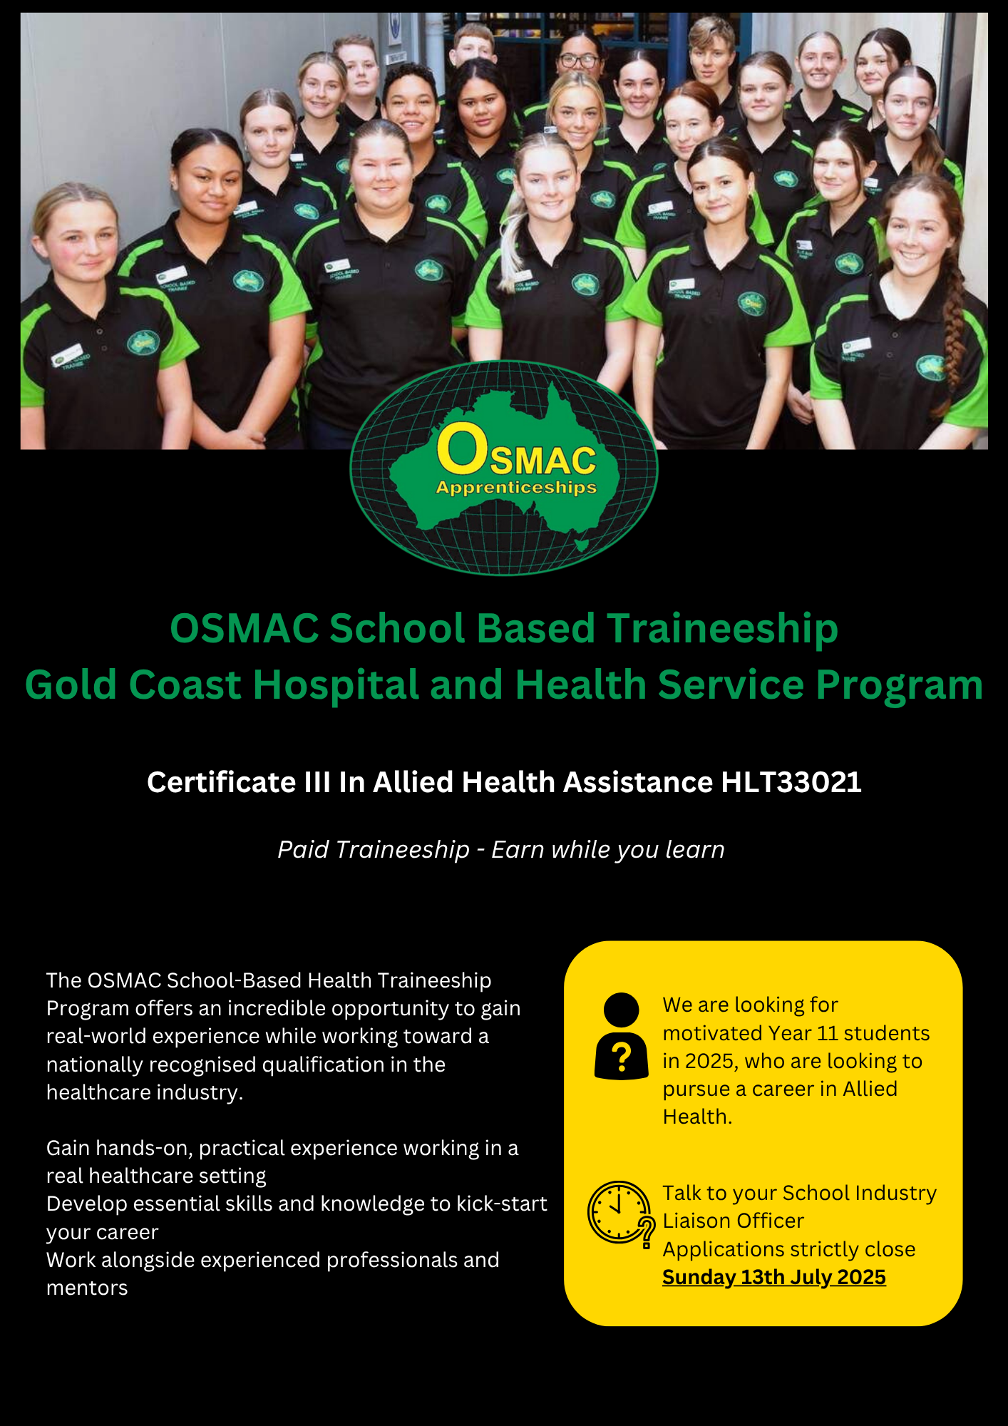
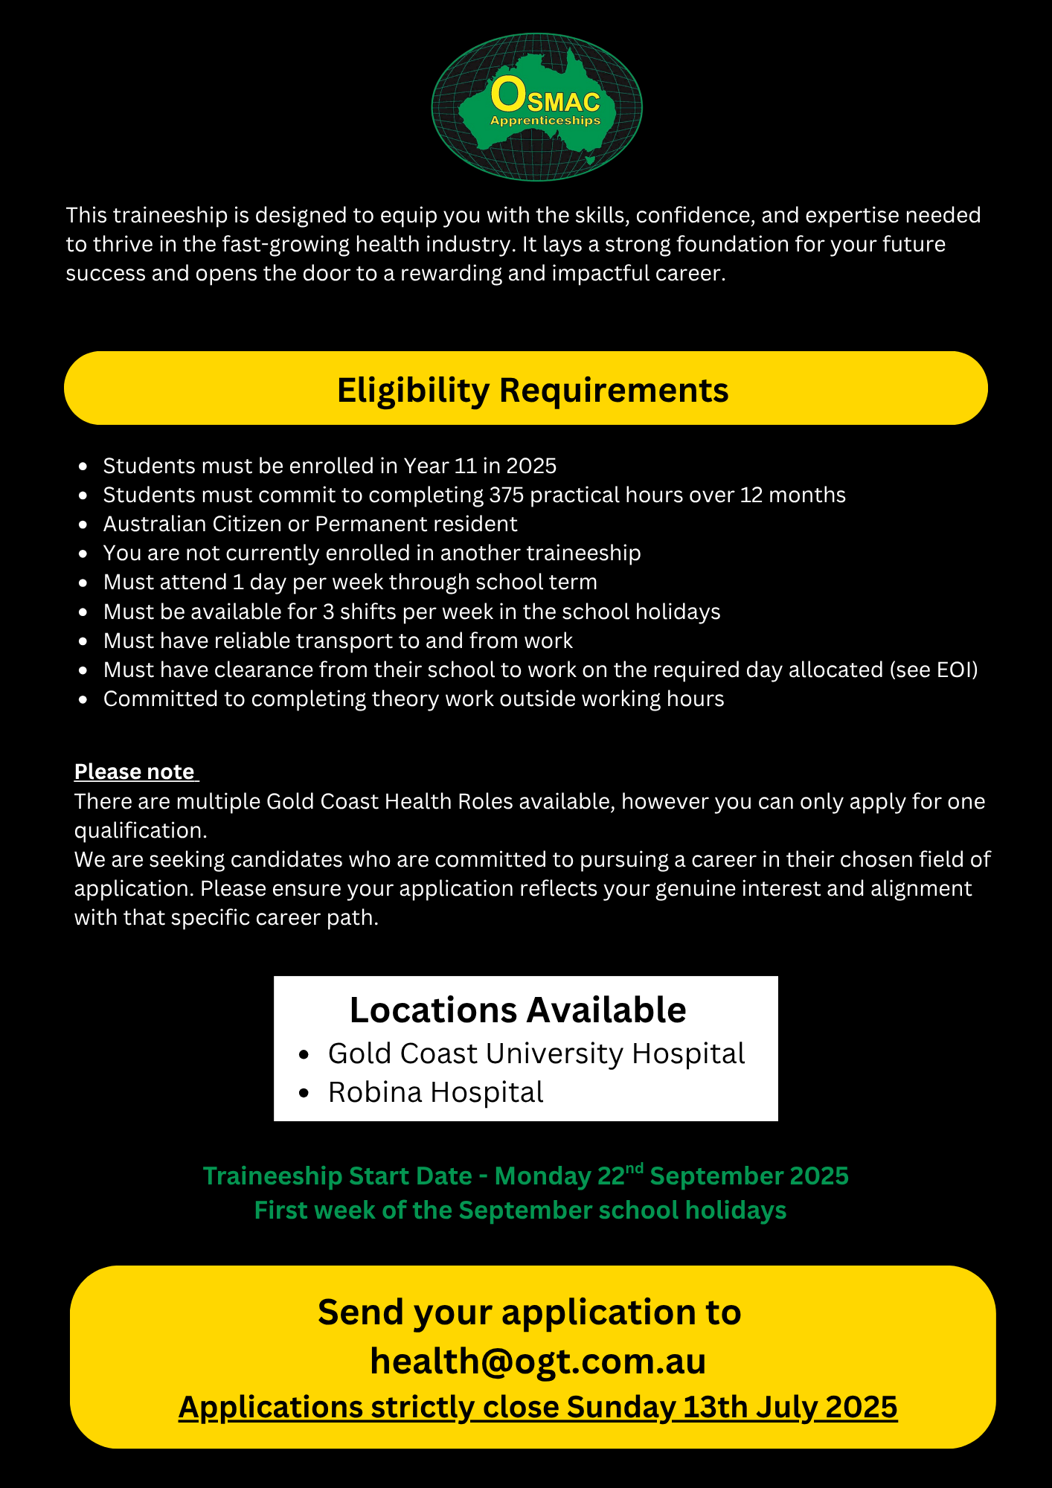

INSERT SCHOOL PHOTO

FIRST NAME:
MIDDLE NAME:
LAST NAME:
NAME OF SCHOOL:
STUDENT SCHOOL EMAIL:
STUDENT PERSONAL EMAIL:
RESIDENTIAL ADDRESS:

MOBILE NUMBER:
CURRENT SCHOOL YEAR LEVEL:
DATE OF BIRTH:
INDUSTRY LIAISON OFFICER /SCHOOL CONTACT NAME & EMAIL:
PARENT/GUARDIAN NAME:
PARENT/GUARDIAN MOBILE:
PARENT/GUARDIAN EMAIL:
USI NUMBER: https://www.usi.gov.au/students/find-your-usi
T -SHIRT SIZE | - XS - SIZE 6  - S - SIZE 8  - M - SIZE 10  - L - SIZE 12  - XL - SIZE 14  - XXL - SIZE 16
WHICH BEST DESCRIBES YOUR WORK TO RIGHT IN AUSTRALIA | - AUSTRALIAN CITIZEN  - AUSTRALIAN PERMANENT RESIDENT  - NZ PASSPORT HOLDER (MORE THAN 6 MONTHS RESIDENCY)  - VISA HOLDER, VISA TYPE NUMBER: _________________
ARE YOU CURRENTLY ENROLLED IN, OR HAVE YOU COMPELTED ANOTHER APPRENTICESHIP OR TRAINEESHIP? | YES / NO
WHAT DAY IS SUITABLE FOR RELEASE FROM SCHOOL (WEEKLY) | - TUESDAY  - WEDNESDAY  - THURSDAY
WHICH DEPARTMENT ARE YOU INTERESTED IN WORKING IN? | - PODIATRY
PLEASE LET US KNOW IF THERE ARE ANY RESTRICTIONS THAT WOULD PREVENT YOU FROM PROVIDING PERSONAL CARE  (EG: ASSISTING WITH TRANSPORT, OR PROVIDING CARE TO BOTH MALE AND FEMALE CLIENTS) | - NO – I DO NOT HAVE ANY RESTRICTIONS  - YES – IF YES, PLEASE EXPLAIN WHICH RESTRICTIONS YOU HAVE AND WHY.
DO YOU IDENTIFIY AS ABORIGINAL/TORRES STRAIT ISLANDER? | YES / NO PLEASE SPECIFY: ___________________

SELECTION CRITERIA – Please take a moment to respond to the following questions in your own words

Criteria 1: Provide an introduction that includes your full name, school, grade, and background (such as family, interests, sports, community involvement, volunteering, and hobbies)

Criteria 2: Why are you interested in applying for the Allied Health Assistance Traineeship? What are your
personal and professional goals, and how will this traineeship help you achieve them?

LITERACY/NUMERACY QUIZ – Please answer the below questions

- Select the most appropriate word to replace the word that is underlined:

Workers in the Allied Health Industry must be careful to ensure patient confidentiality.

- Gossip
- Lies
- Conversation
- Privacy

- A client needs their medication every 4 hours. The first dose is given at 6:00 AM. At what times should
the next three doses be given?

- 10.00am, 12.00pm, 2.00pm
- 11.00am, 3.00pm, 7.00pm
- 10.00am, 2.00pm, 6.00pm

- You begin preparing a therapy room at 8:45 AM. It takes 10 minutes to clean the equipment, 15 minutes to set up the space, and another 5 minutes to review patient notes.
What time will you be finished with all your preparations?

ANSWER: _____________________________________________________________________________

- Your client needs to complete a therapy plan that includes:

40% Strength Exercises
35% Mobility Training
25% Hydrotherapy

If they attend 20 sessions in total, how many sessions will be dedicated to each type of therapy?

ANSWER: _________ Strength Exercises
_________ Mobility Training
_________ Hydrotherapy

- You are given the following tasks at the start of your shift. In what order should you complete these tasks? Justify your choices based on safety, professionalism, and clinical priorities.

- A client is waiting in the therapy room for you to assist with stretching
- Equipment from the last session has not been cleaned
- The supervising physiotherapist asks you to bring a new client’s file within the next 10 minutes
- You haven’t completed your hand hygiene or checked your schedule

ANSWER: _1.____________________________________________________________________________
_2.____________________________________________________________________________
_3.____________________________________________________________________________
_4.____________________________________________________________________________

- The maximum safe lifting weight for an allied health assistant is 16kgs. A box of therapy balls weighs 11.5 kg and a folded walking frame weighs 5.2 kg. Can you carry both items at the same time?

ANSWER: _____________________________________________________________________________

- Match the PPE (personal protective equipment) item with its purpose:

PPE Item | Purpose
Gloves = ____ | A. Protect eyes from splashes
Face mask = ___ | B. Protect hands from contact with bodily fluids
Goggles = ___ | C. Prevent transmission through breathing/coughing
Gown = ___ | D. Protect clothing from spills and contamination

- Based on the list below, which of the following procedures for washing your hands is in the correct order?

Step 1 - When soap has foamed, rinse well with water.
Step 2 - Dispose of the paper towel correctly.
Step 3 – Thoroughly rinse hands with water.
Step 4 – Dry hands thoroughly using a clean paper towel.
Step 5 – Use medicated hand wash and rub thoroughly over both hands for 20 seconds.

- Step 2, Step 3, Step 4, Step 1, Step 5
- Step 3, Step 4, Step 5, Step 1, Step 2
- Step 3, Step 5, Step 1, Step 4, Step 2
- Step 5, Step 2, Step 1, Step 3, Step 4

- You notice that a client's wound dressing is soaked through and starting to come off. As an Allied Health Assistant, what should you do?

- Remove the dressing and replace it with a clean one
- Ignore it, since the client hasn’t complained of pain
- Inform the supervising nurse or clinician immediately
- Tape it down tightly so it doesn’t fall off

- You are assisting Mr. Taylor with walking into the clinic using a 4-wheeled walker. He begins walking slower, becomes short of breath, and says, “I don’t feel quite right.” What should you do first?

- Encourage him to keep going so he doesn’t lose momentum
- Tell him to sit down immediately and call for help if needed
- Ask him to finish the walk quickly and rest afterward
- Go and have your lunch break

- Your client weighs 68.5 kg in the morning and weighs 69.2 kg the following day. How much weight did the client gain?

ANSWER: _____________________________________________________________________________

- Your shift at the hospital starts at 7.00am and finishes at 3.00pm. You get a 30-minute unpaid lunch
break per shift. What is the paid duration of your shift?

- 8 Hours
- 7.5 Hours
- 7 Hours

- Which of the following uses the correct medical terminology for describing a client's condition?

- "The client had a sore leg and felt funny."
- "The patient said their leg was a bit off and they were dizzy."
- "The client reported lower limb pain and dizziness."
- "The person felt bad, and their leg was hurting."

Medical History

OSMAC Group Training is aware of its obligation to anti-discrimination legislation and information provided by applicant will be used in a manner complimentary to the fulfilment of those obligations.

Have you ever suffered from?

Yes |  | No |  | Back Problems
Yes |  | No |  | Bronchitis
Yes |  | No |  | Migraines
Yes |  | No |  | Dermatitis
Yes |  | No |  | Eyesight
Yes |  | No |  | Arthritis
Yes |  | No |  | Asthma
Yes |  | No |  | Epilepsy
Yes |  | No |  | Hearing Problems
Yes |  | No |  | Fainting/ Blackouts

List all injuries, illnesses and allergies that you have suffered from?
Do you have any fear of heights or confined spaces?
Do you require any reasonable adjustment to effectively perform the duties of the traineeship? If yes, are you able to please list them so we know how to best support you?

Are you willing to undergo a preemployment medical inclusive of drug and alcohol testing?

- Yes
- No

Statement by Applicant
I, the undersigned declare that the above information has been answered truthfully and to the best of my knowledge. I further understand that if false or misleading information has been supplied it may result in the termination of my employment.

Student Signature: | Date:

Please sign below to confirm that you are available on the designated training day, weekly, as well as up to 3 days per week during the school holidays.

Please note that all trainees must have reliable and sufficient transportation to attend their scheduled shifts and RTO training sessions. If a trainee is unable to meet this requirement, we reserve the right to cancel the traineeship. It is the trainee’s responsibility to ensure they can consistently commute to and from work for the duration of the program.

Students who are successful securing a traineeship will be required to complete the following prior to commencing their traineeships:

- National Police Check (paid by trainee upfront, reimbursed by OSMAC)
- Blue Card (paid for by OSMAC)
- Film Consent Form
- VPD Vaccination Forms

Student Signature: ___________________________________

Guardian Signature: __________________________________

Please include the following supporting documentation with your expression of interest:
- Copy of your Resume
- Cover Letter
- Most recent school report card
- Letter of recommendation from your school confirming their support for you to attend the traineeship on the designated day

Please ensure that this expression of interest is completed in full; incomplete applications will not be considered.

Email your application and supporting document in one email to;
health@ogt.com.au

