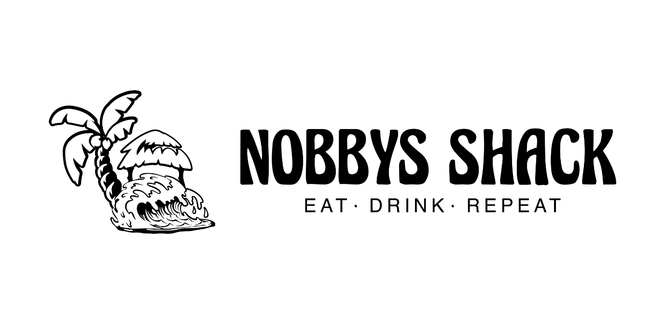
🌟 Calling all students! 🌟

Looking for an exciting opportunity to gain hands-on experience in the world of hospitality? Look no further than 'Nobbys Shack'!

No experience necessary! We're searching for students with a genuine interest in hospitality and a willingness to learn. If you're hardworking, eager to develop your skills, and ready to dive into the world of coffee and food, this traineeship is for you!

And here's the best part: Students who join our traineeship program get a day off from school to actively learn by working at 'Nobbys Shack'! Plus, you'll be paid for your valuable time and effort.

Don't miss out on this incredible opportunity to kickstart your career in hospitality while having a blast at the same time!

