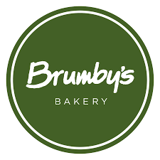

Brumby’s Bakery is one of Australia’s most well-known bakeries for serving warm and fresh baked goods daily. Brumby’s takes the freshest and highest quality grain and bakes it into the warm and fresh bread we know today.

Now they are looking for trainees for their Varsity Lakes Christine Corner store and Easy T store. You could earn while you learn and work towards a Certificate III in Business.

If you portray an upbeat, dedicated, bubbly and hard-working mindset, then apply today! For further details contact Mrs Hart at rhart134@eq.edu.au

