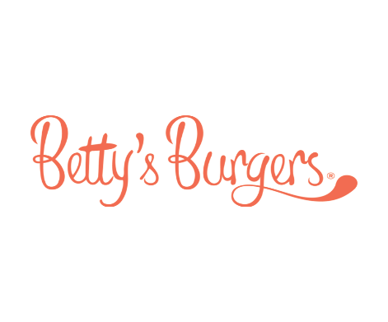
Christmas casual opportunities available within our kitchen team at Pacific Fair
Casual positions available in our front of house team at Robina
What we are looking for…
- Someone with a positive and energized work ethic
- Flexible holiday hours
- No need for any previous experience, but if you have it great!!
Come down after school and hand in your resume

WE HOPE TO SEE YOU HERE, WORKING FOR US THESE HOLIDAYS
Phone: (07) 5592 2754
Email: xiank@bettysburgers.com.au

