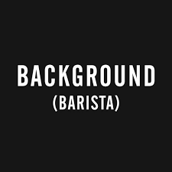

Background Barista and are looking for hard working students to fill roles during the busy period over Christmas and potentially beyond. Preferably students who have a genuine interest in cooking, barista skills, must be reliable and/or hospitality in general.

If you are interest, please contact Kym or Adam or email your resume through.

Kym - 0414957956

Adam - 0407258997

backgroundbarista@outlook.com