 | Certificate II in Leather Production  MST20319 |  |  | VET
 |  | Tactile Learning Centre Pty Ltd  RTO No: 30922 | 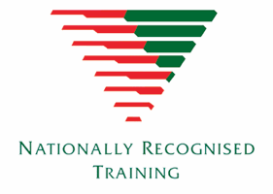

This entry level qualification in Leather Production can take you into a variety of trades like leather production, shoe repairing, and orthopaedic or bespoke shoemaking. But it can also launch you anywhere in the TCF (Textile, Clothing and Footwear) industry like fashion design, textile production or even millinery.
If you enjoy making things by hand and are interested in entering the Textile, Clothing & Footwear industry, this course is for you!
Refer to training.gov.au for specific information about the qualification.

Pathways
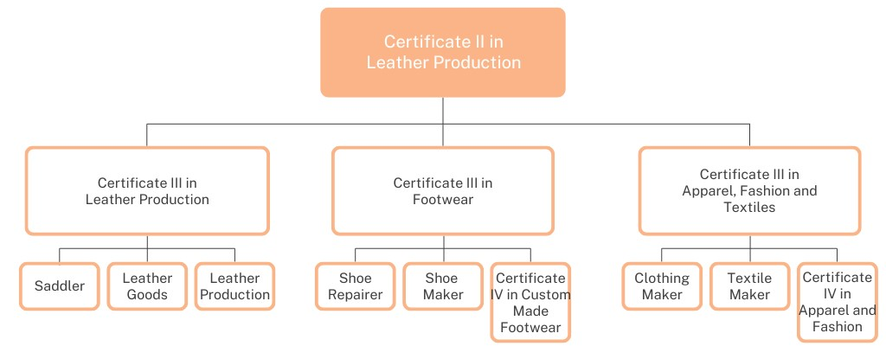

Entry requirements
There are no entry requirements for this qualification. At enrolment students will need to provide their Unique Student Identifier (usi.gov.au) and complete an LLN test to determine suitability and any support needs.
Duration and location
This is a 9 month course delivered in year 11 on site with qualified trainers via a third party arrangement with Tactile Learning.
Fees
VETiS funding option – no training cost for eligible students
QCE Points
Maximum of 4 credits.

Course Units
Students must successfully complete all 13 units of competency (5 core units plus 8 elective* units) to attain this qualification.
Unit code | Unit title
MSMENV272 | Participate in environmentally sustainable work practices
MSS402051 | Apply Quality Standards
MSTGN2018 | Work in the TCF Industry
MSMWHS200 | Work safely
MSTGN2022 | Perform Tasks to Support Production
MSMSUP106* | Work in a team
MSTGN3012* | Work safely with chemicals in TCF operations
MSTGN2020* | Perform test or inspection to check product quality
MSTLG2003* | Perform table work
MSTLG2006* | Identify materials used in leather goods production
MSTLG2007* | Skive leather pieces
MSTLG3002* | Cut leather by hand
MSTGN2021* | Select, transfer and remove materials and products
Delivery modes
A range of delivery modes will be used during the teaching and learning of this qualification. These include:
- face-to-face instruction
- practicals and scenarios
- online training
Assessment
Assessment is competency based. Assessment techniques include but not limited to:
- observations
- folios of work
- questionnaires
- written and practical tasks
- Students will need to demonstrate the ability to swim a set distance and tread water.
Obligation
Students will be provided with every opportunity to complete the qualification. Employment is not guaranteed upon completion. Students deemed competent in all units of competency will be awarded the qualification and a record of results by Australian Global Institute Pty Ltd. Students who achieve at least one unit of competency (but not the full qualification) will receive a Statement of Attainment

